(Company Name) Business Response to COVID-19

This plan is based upon the risk classification associated with the manufacturing operation of (insert company name) located at (insert address). The jobs at this location are considered to be of a Lower to Medium Exposure Risk, i.e. workers are not within 6 feet of someone known, or suspected to have, SARS-CoV-2, and not performing body fluid aerosol-generating procedures. (see Guidance on Preparing Workplaces for COVID-19, OSHA 3990-03 2020 for further details on all risk levels and CDC Interim Guidance for Businesses and Employers to Plan and Respond to Coronavirus Disease 2019 (COVID-19)).

The plan identifies the necessary policies, practices, and conditions necessary to meet the Centers for Disease Control and Prevention (CDC) and guidelines for COVID-19, federal Occupational Safety and Health Administration (OSHA) standards. The plan has the strong commitment of management and is being implemented with the participation of our employees.

- Infectious Disease Preparedness and Response Plan
  - An assessment of the level of risk associated with various worksites and job tasks has been performed
    - Sources of SARS-CoV-2 exposure at the workplace
- Co-workers
- Anytime employees are within six feet of each other
- Necessary work functions that bring employees within six feet of each other
- Employee breaks
- Employee lunch

- Functions where social distancing is difficult to maintain
  - interplant truck driver
  - receiving
  - shipping
  - other

- Visitors
  - Vendors
  - Customers
  - General Public

- Business travel

    - Non-occupational risk factors at home and in community
      - Social interaction outside of work

    - Workers’ individual risk factors
      - Personnel with a health condition that may place them at high risk

  - Controls designed to address risk to employees in the workplace.
    - Co-workers
- During the workday, all employees must maintain six feet of distance between each other when and where possible.
- On the production floor employees should strive to conduct their duty without coming within 6 ft of a co-worker. All employees that are within six-foot of one another, due to a need for assisting with a necessary work function, will be required to wear face protection/mask.
- Employees are encouraged to take breaks at their work area. If breaks are taken in a break area, all employees must maintain six feet of distance between each other
- Everyone is encouraged to eat alone at their workstations.
- All office personnel who can work from home will do so.

    - Areas or functions where social distancing is difficult to maintain such as interplant truck driver, receiving, shipping, other
      - All entrants into the building for these purposes will be required to wear face protection. Any employee interacting with these entrants will be required to wear face a face mask. When the visitor has left the building, flat surfaces will be sprayed down, pens for signing will be wiped, with disinfectant and any items received will be sprayed down, if possible.
    - Vendors, Customers, and the General Public
      - Visitation by non-critical visitors is discouraged.
      - All Entry and Exit from the building will be recorded on Visitor Logs (see Attachment 1). Logs will be located at both front and rear entrance of building with disposable masks, a pen and hand sanitizer located next to it. All visitors are expected to wear a face mask and signs are posted for notification (See Attachment 2).
      - Any visitor arriving at our facility and showing signs of sickness will be turned away.
      - Visitors are to practice social distancing and remain 6 ft. away from employees while in the facility.

    - Business travel has been suspended. Normal communication with customers and suppliers will be via conference calls or video conferencing apps.

    - Non-occupational risk factors at home and in community
      - Everyone is highly encouraged to follow the NYS Stay at Home and social distancing guidelines when not working.

    - Workers’ individual risk factors
      - All personnel who have a health condition that may place them at high risk are asked to contact their primary health care provider for guidance. You may then contact your supervisor and/or Human Resources to discuss your personal situation. People at higher risk for severe illness are:
        - Those of age > 65
        - Those with chronic medical conditions, i.e. asthma or lung disease, heart conditions, immunocompromised, severely obese (BMI>40), diabetics, those with liver or kidney disease undergoing dialysis, other

  - Procedure to check welfare and health of workforce
    - Supervisors are responsible for asking each employee, every day, if they are well and if they are experiencing any flu-like or COVID-19 symptoms.
      - Questions to include feelings of any Covid or flu-like symptoms, contact with a confirmed Covid19 case within the last 14 days and if anyone in the household is currently in isolation for Covid-type symptoms.

    - Supervisors and Human Resources will train, and consistently communicate to workforce the importance of employee self-reporting feelings of illness of any type.

  - Procedure to address a suspected infection
    - See #3 - Policies and procedures for prompt identification and isolation of sick employees

  - Outbreak contingency plan to deal with:
    - Increased absenteeism
      - Cross training will be conducted across multiple employees for any critical operations, bottleneck work centers, and/or jobs with no current back-up workers.

    - Social Distancing
      - Breaks and lunch times will be staggered in such a way that discourages people from forming high density assemblages.
      - Across various areas of production, and in lunch and break areas, markers will be placed on the floor demonstrating a six-foot distance.
      - In all office areas, bright yellow tape will be applied to floor moulding at six-foot intervals as a visual cue for good distancing practices.

    - Interrupted supply chains
      - Alternate domestic suppliers will be identified, and qualified, for all critical materials and outsourced processes.

- The following basic infection prevention measures will be implemented
  - Frequent and thorough hand washing will be required.
    - Workers, customers, and worksite visitors will be provided with a place to wash their hands.
    - Where soap and running water are not immediately available, alcohol-based hand rubs containing at least 60% alcohol will be provided.

  - Employees are required to wash their hands upon entering the building.
  - Workplace disinfection
    - Disinfecting wipes are provided for employees to clean their immediate area before starting their shift, and upon ending their shift.
    - Cleaning and disinfecting products are available to employees to keep work areas disinfected throughout the day.
    - If employees are working in same area as another employee, they must wipe common surfaces after every break and tooling after final use.
  - Workers are required to stay home if they are sick.
  - Respiratory etiquette is required, including
    - Cover all coughs and sneezes.
    - Hand cleaning post cough or sneeze is required.
  - Workers, vendors, Customers and the public will be provided with tissues and no-touch trash receptacles.
  - Workers will be prevented from using other workers’ phones, desks, offices, or other work tools and equipment, unless the aforementioned is completely disinfected.
  - Regular housekeeping practices will be maintained, including
    - routine cleaning and disinfecting of all frequently touched surfaces, equipment, and other elements of the work environment.
    - Only Environmental Protection Agency (EPA)-approved disinfectant cleaning chemicals will be chosen labels.
  - Hand hygiene
    - Soap and water are provided in multiple areas of the workplace.
    - Alcohol-based hand sanitizer that is at least 60% alcohol is available in public use areas of the building.
    - If hands are visibly dirty, soap and water should be chosen over hand sanitizer.
    - Posters are in place that encourage hand hygiene to help stop the spread in workplace areas where they are likely to be seen.
  - Handshaking and other casual contact between employees or visitors is not allowed. Rather the use of other noncontact methods of greeting are encouraged.
  - Employees are directed to visit the coughing and sneezing etiquette and clean hands webpage for more information (https://www.cdc.gov/healthywater/hygiene/etiquette/coughing_sneezing.html)

- Policies and procedures for prompt identification and isolation of sick employees
  - All employees must self-monitor for signs and symptoms of COVID-19 if they suspect possible exposure (See Attachment 3).
    - Attachment 3 will be printed and posted in multiple areas around the organization.

  - Employees reporting sickness.
    - If home, any employee is feeling symptoms of this illness must contact their supervisor and Human Resources immediately and DO NOT report to work. Employee will be advised contact their primary care provider.

    - If at work, employees should follow company procedure for reporting and isolating, including reporting symptoms to their supervisor and immediately leave the facility and go home to self-isolate. Supervisor will inform HR. HR will contact the employee to gain information as to who the employee interacted with (in the workplace), how long the employee has had symptoms and ask the employee to contact their primary care provider.

    - Employee should not be allowed to return to work until such time as the appropriate health official has provided written clearance to do so.

  - Isolation of symptomatic employee
    - If an employee shows signs or symptoms or reports any sign or symptom of COVID-19 while at work, that employee will be immediately isolated in the designated isolation room.

    - Employee will there until a ride is able to pick them up, or safely escorted to the office door and sent home to contact their primary care provider.

    - Immediately upon employee egress, the isolation room will be properly disinfected.

  - If a symptomatic employee is confirmed to have COVID-19 infection
    - Human Resources (HR) will inform fellow employees of their possible exposure to COVID-19 in the workplace but maintain confidentiality as required by the Americans with Disabilities Act (ADA).

    - HR will instruct fellow employees about how to proceed based on the CDC Public Health Recommendations for Community-Related Exposure. https://www.cdc.gov/coronavirus/2019-ncov/php/public-health-recommendations.html
- If a sick employee is suspected or confirmed to have COVID-19, the CDC cleaning and disinfection recommendations will be followed for cleaning their workplace (See Attachment 4, and https://www.cdc.gov/coronavirus/2019-ncov/community/disinfecting-building-facility.html).
- Employees will not return to work until the criteria to discontinue home isolation are met, in consultation with healthcare providers and state and local health departments.
- Employees who are well but who have a sick family member at home with COVID-19 should notify their supervisor and follow CDC recommended precautions.

- Workplace flexibilities and protections
  - If an Employee is sick, we require the employee to stay home until they are feeling better, have no symptoms or elevated temperature.
  - Sick leave policies are flexible and consistent with public health guidance and employees are made aware of these policies via email and bulletin board postings.
  - Before utilizing any temporary employees, we will talk with companies that provide our business with contract or temporary employees about the importance of sick employees staying home and encourage them to develop non-punitive leave policies.
  - We will require a healthcare provider’s note for employees who are sick with acute respiratory illness to validate their ability to return to work.
  - We will maintain flexible policies that permit employees to stay home to care for a sick family member including of Family and Medical Leave Act (FMLA), Paid Family Leave (PFL), Families First Coronavirus Response Act (FFCRA) leaves, or Paid Time Off (PTO) per HR policies. We are aware that more employees may need to stay at home to care for sick children or other sick family members than is usual.

- Implementation of workplace controls
  - Engineering controls – does not rely upon worker behavior, i.e. isolation of employees from work-place hazards
    - All visitors will wear face masks while on company property
    - Any work centers that cause employees to come withing 6 feet of each other will be moved and/or redesigned to provide a minimum of 6 feet of separation or install physical barriers as appropriate.
    - Any other operations or duties, that bring people within 6 feet of each other, require those individuals to use appropriate Personal Protective Equipment (PPE) and disinfection procedures. See supervisor if there are questions.
  - Administrative controls
    - Sick workers are to stay at home.
    - Virtual communications and telework will be used when feasible.
    - Alternating days and extra shifts will be employed to reduce the number of employees in a facility at any given time as needed.
    - Travel to locations with ongoing COVID-19 outbreaks has been discontinued.
    - Current emergency communications plans are to be utilized. Important communications will be distributed via email, as well as posted in all areas.
    - Worker education and training on COVID-19 risk factors and protective behaviors (e.g., cough etiquette and care of PPE) will be provided via email and/or bulletin board postings.
  - Safe work practices - procedures for safe and proper work
    - Resources are provided as well as work environment that promotes personal hygiene. For example, we provide tissues, no-touch trash cans, hand soap, alcohol-based hand rubs containing at least 60 percent alcohol, disinfectants, and disposable towels for workers to clean their work surfaces
    - Requiring regular hand washing or using of alcohol-based hand rubs. Workers should always wash hands when they are visibly soiled and after removing any PPE.
    - Handwashing signs are posted in restrooms (See Attachment 5).
  - Personal protective equipment – as needed. We will provides all workers with PPE needed to keep them safe while performing their jobs. The types of PPE required during a COVID-19 outbreak will be based on the risk of being infected with SARS-CoV-2 while working and job tasks that may lead to exposure. The PPE provided is:
    - Selected based upon the hazard to the worker
    - Properly fitted and periodically refitted, as applicable (e.g., respirators)
    - Consistently and properly worn when required

- We will continue adherence to all existing OSHA standards
a. https://www.osha.gov/

ATTACHMENT 1

(Company) Visitors Log

First Name | Last Name | Company Representing | Point of Contact | Date

ATTACHMENT 2

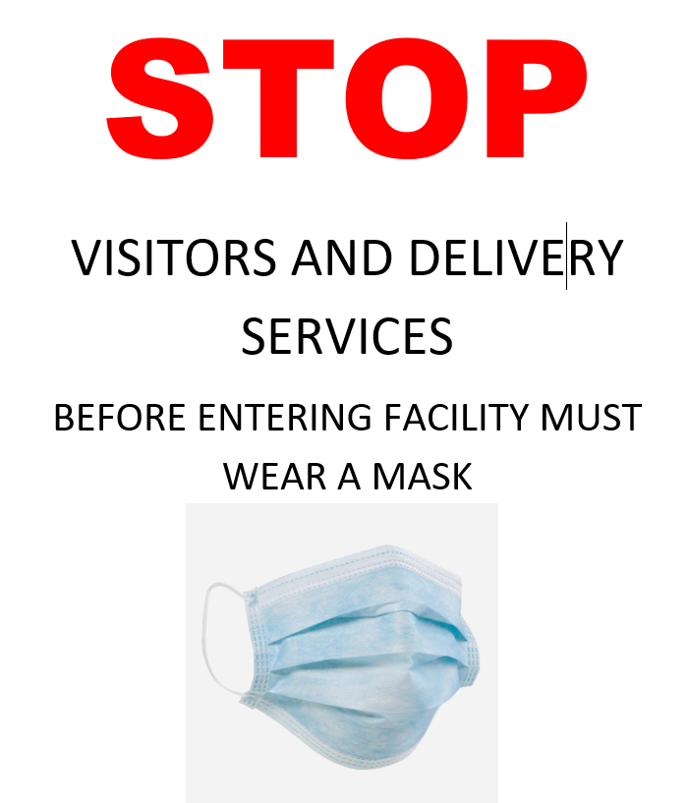

ATTACHMENT 3

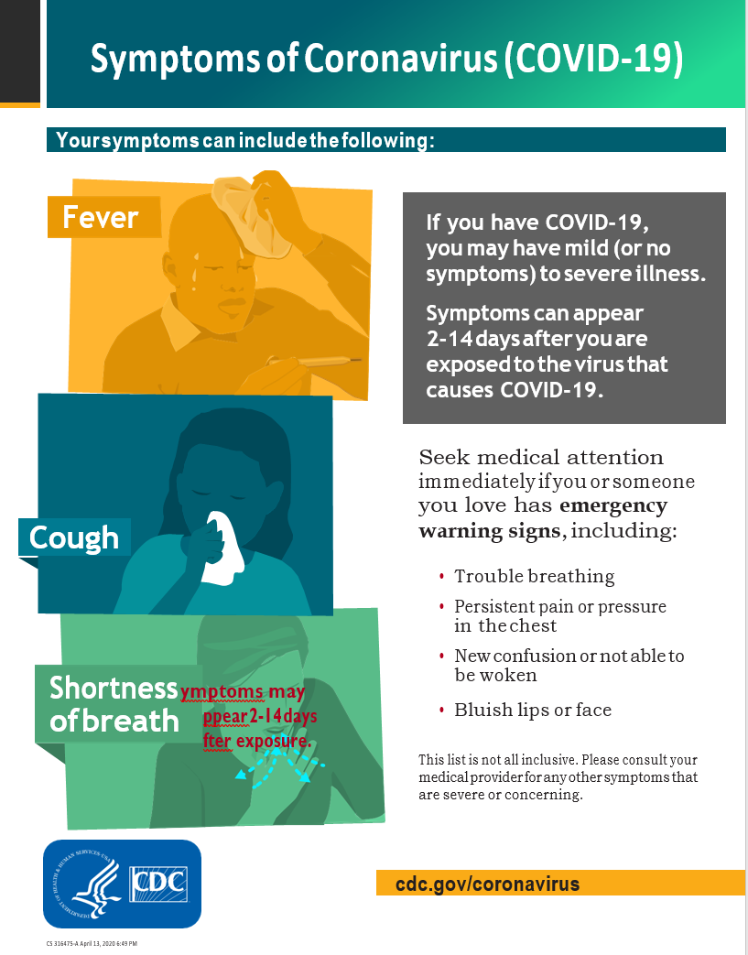
ATTACHMENT 4

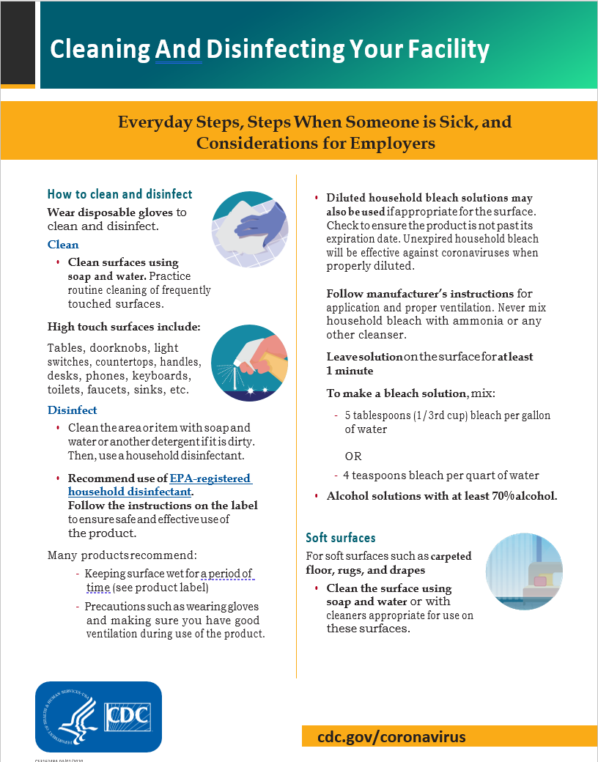
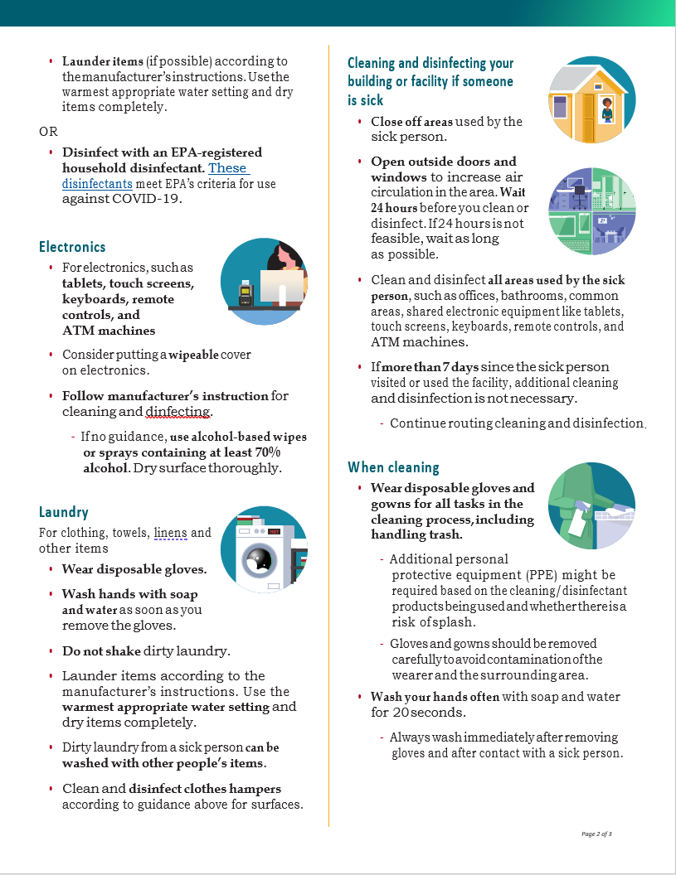
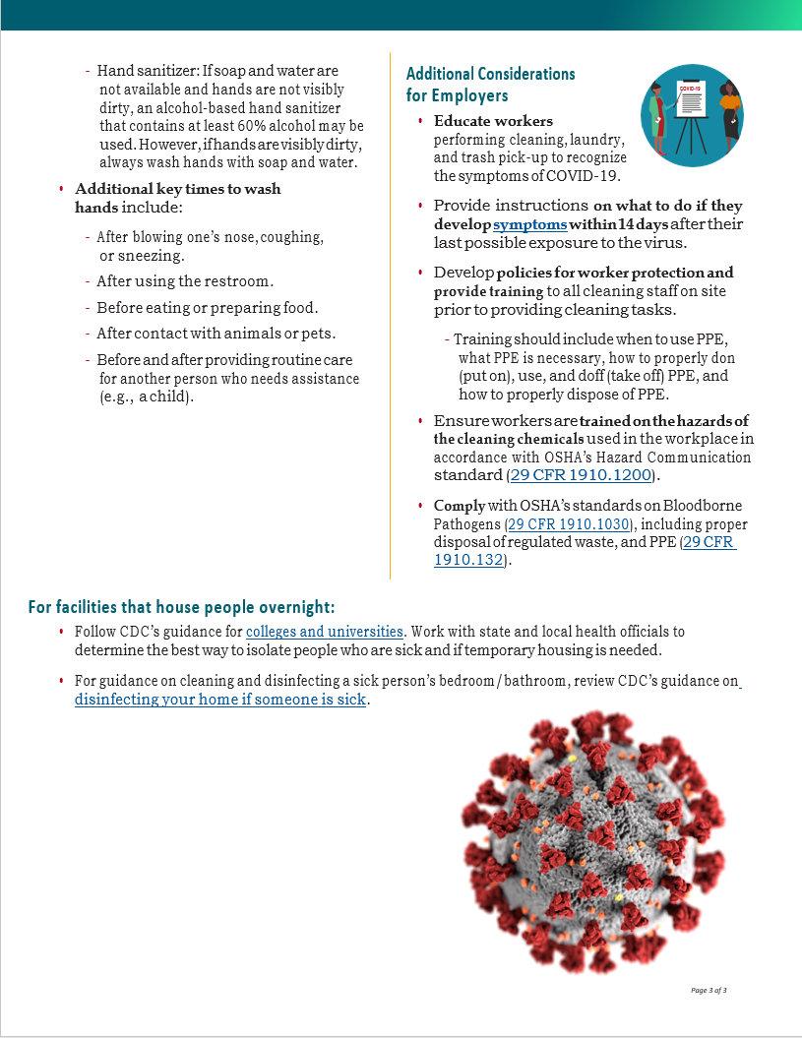

ATTACHMENT 5

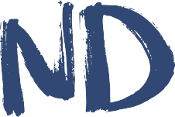
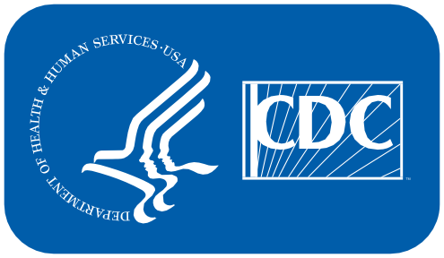
LIFE IS BETTER WITH

CLEAN HANDS KEEP YOU HEALTHY.
Wash your hands with soap and water for at least
20 SECONDS.

www.cdc.gov/handwashing

This material was developed by CDC. The Life is Better with Clean Hands Campaign is made possible by a partnership
between the CDC Foundation, GOJO, and Staples. HHS/CDC does not endorse commercial products, services, or companies. CS309599A

